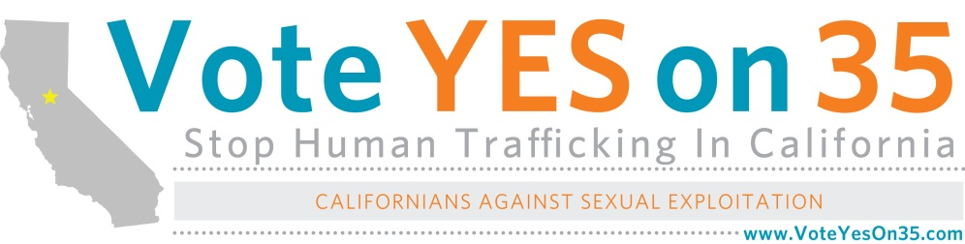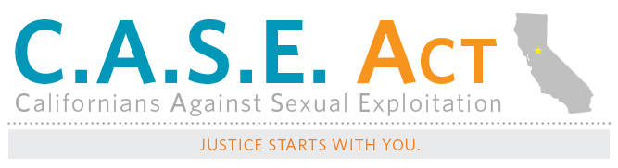P.O. Box 7057

Fremont, California 94537

(510) 473-7283 (510-iRESCUE)

info@CASEAct.org

FREQUENTLY ASKED QUESTIONS

Slated for the November 2012 ballot, Proposition 35 is an initiative that will fight back against human trafficking and the sexual exploitation of women and children.

**Who are the sponsors of Proposition 35?**

Proposition 35 is a joint effort between California Against Slavery and the Safer California Foundation.

**California Against Slavery** (CAS) is a nonprofit, non-partisan human rights organization dedicated to ending human trafficking in our state. Our mission is to defend the freedom of every child, woman and man by empowering the people of California to fulfill our obligation to stop human trafficking.

**The Safer California Foundation** is dedicated to supporting efforts to protect Californians from all forms of criminal exploitation. Created by Chris Kelly, former Facebook Chief Privacy Officer and a Silicon Valley attorney and philanthropist, the Safer California Foundation looks forward to the day when every neighborhood in California is as safe as our most secure neighborhoods today.

**Who endorses Proposition 35?**

Proposition 35 is endorsed by a growing list of law enforcement and advocacy groups. To view our full list of endorsements or sign up your organization, please visit our [Endorsements page](http://californiaagainstslavery.org/initiative/).

**Why not lobby?**

**Raising awareness:** As a proposition on the ballot, the initiative will dramatically raise awareness and unite Californians to take action against human trafficking and sexual exploitation where we live. In addition, experts agree that voters will show overwhelming support for the initiative when it is on the ballot.

**Learning from experience:** Due to the current political climate, bills with enhanced prison penalties will not pass the legislature. Similar measures have not passed.

**Who is funding the initiative?**

The initiative is funded through the generous contributions of citizens throughout California. Major funding is from Chris Kelly, the Safer California Foundation.

**How much will it cost California if this initiative passes?**

According to the Legislative Analysis Office, the cost is “minor…of incarcerating and supervising human trafficking offenders.” There would be potential one-time local costs of up to a few million statewide for police training.

The better question is how much it would cost California if we ***don’t*** pass this initiative. Victims of such severe abuse and torture often need a lifetime of medical and counseling services. The healthcare cost for one victim is tremendous, according to Dr. Sharon Cooper, Forensic Pediatrician. A trafficker has multiple victims. By putting one trafficker behind bars, we can save and prevent many victims. Also, victims often end up in our prison system for prostitution and other crimes which is a cost to us.

Lastly, there is the price of opportunity lost. These victims can be our future lawyers, business woman or man, doctors, etc. The cost of them not reaching their potential is significantly higher than any cost to prevent their abuse. And it’s the right thing to do. Victims are counting on you.

**Why do this when California already has a prison overcrowding issue?**

Human trafficking is not a petty crime. It is a brutal human rights abuse. Traffickers, driven by greed, are instigating rape and torture on children and women, and treating people like lifeless and soulless things. **The prison was made for people like them.** Yes, our prison system must be fixed. But this is a separate issue. Just as we don’t tell our children to stop going to school because our educational system is broken, we cannot tell victims that they can continue to be abused and tortured because our prison is overcrowded. How can we?!

**How will Proposition 35 strengthen the law?**

**The proposed measure will:**

* Increase prison terms for human traffickers
* Increase fines for human traffickers, up to $1.5M to fund victim services
* Remove the need to prove force to prosecute sex trafficking of a minor
* Mandate human trafficking training for law enforcement
* Make sex traffickers register as sex offenders
* Require that all sex offenders to disclose internet accounts
* Prohibits use of sexual history to impeach or prove criminal liability of trafficked victims

**Begin a movement for justice:**Proposition 35 will result in the single largest movement against human trafficking in our country and would be the toughest anti-human trafficking law in the country. 17 million registered voters in California can make a firm statement to traffickers around the world that we take slavery seriously and care about those in bondage.

**How does Proposition 35 compare to current state and federal laws?**

Current state penalties do not reflect the severity of the crime nor do they hold criminals accountable. Proposition 35 will bring current state law up to the federal standard.



**Why not use the Federal law?**

The federal law against human trafficking, called the “Trafficking Victims Protection Act of 2000″ (TVPA), applies only to federal cases, which are required to be tried in federal courts, by federal prosecutors. Each state is responsible for enacting its own legislation to handle cases within the state. Even if state cases could be tried in federal court, there are very few federal resources available. For example, there are only four U.S. attorneys’ offices located here compared to California’s 58 state district attorneys and over 4,000 prosecuting attorneys.

**Does human trafficking really happen here?**

**Human trafficking in California**

California is a hot spot for domestic and international human trafficking because of its large population, international borders, large economy, extensive ports, and metropolitan regions. According to a study by the FBI in 2003, California is home to three of 13 high-intensity child sex trafficking cities: Los Angeles, San Francisco and San Diego.

**Who are the victims? Who are the traffickers?**

**Victims**

Victims of human trafficking are both U.S. citizens and foreign nationals. Victims can be anyone from any community, race, and gender. However, the average sex trafficking victims in the U.S. are runaway girls between 12 to 14 years old who have already suffered sexual abuse as children. Victims that are minors or mentally delayed tend to be easy targets and carry less risk for the traffickers and buyers than adults and foreign nationals.

**Traffickers (criminals)**

Traffickers tend to be either from the same community/ethnicity as the victims or speak their language.

The pimps are master manipulators who gain a victim’s trust before forcing them into trafficking and keeping them compliant through violence and drugs.

**What can I do about this?**

**How do I get involved with the Proposition 35 campaign?**

We need your help!  [Sign up to volunteer](http://www.caseact.org/volunteer/).

What do I do if I suspect human trafficking?

If you suspect human trafficking, call your local police department and/or the National Human Trafficking Resource Center hotline at 1-888-3737-888. The hotline is open 24 hours a day, 7 days a week and you can leave a tip anonymously.